Name:吳宜芬

Student ID:7106056001

Basic

1. Tell me how to run your program

sudo ./hw4 10.0.2.15 or

sudo ./hw4 140.120.13.1

1. Please describe the details about your program

使用socket(PF_INET,SOCK_RAW,1)，建立連線

設定server_addr.sin_addr.s_addr = inet_addr(target);

為目標server的ip addr

設定icmp的type=13,cksum=0,id=123,otime=gettime();

計算cksum放到cksum裡

sendto server

接收跟自己送出去的icmp一樣id且type=14的回傳封包

取出

T1=otime

T2=rtime

T3=ttime

T4=目前的gettime

RTT=(T4-T3)+(T2-T1)

1. Show the execution result (snapshot)

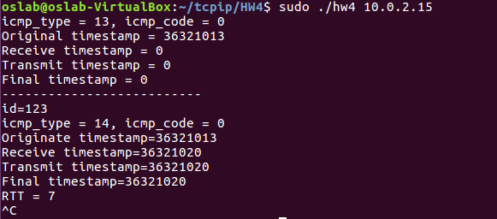

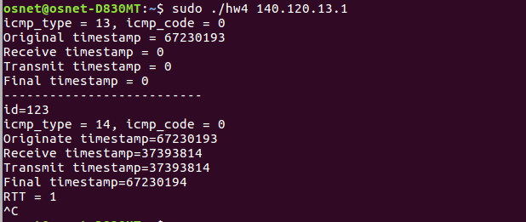

Advanced

1. Tell me how to run your program
2. Please describe the details about your program
3. Show the execution result (snapshot)